CHAPTER-1 INTRODUCTION

1.1 Significance of modern life style on personal wellbeing
In recent years, the intricate interplay between community health and societal wellbeing has become increasingly apparent. The cornerstone of a prosperous society lies in the health and contentment of its populace. However, contemporary lifestyles often force individuals to prioritize other responsibilities, resulting in a concerning lack of awareness regarding their wellbeing. This challenge has assumed unprecedented urgency amidst the ongoing COVID19 pandemic [1], highlighting the critical necessity for innovative solutions in remote medical care. Central to our endeavour is the recognition of the intrinsic connection between community health and societal wellbeing. We emphasize the fundamental importance of maintaining physical wellbeing for fostering overall happiness and cognitive function within communities. Yet, the realities of modern life often lead individuals with busy schedules to overlook their health needs and remain unaware of their current health status. The intersection of technology and healthcare has witnessed remarkable advancements in recent years, catalysing transformative changes in medical service delivery. Amidst the global challenges posed by the pandemic, the innovative solutions to address healthcare needs has become more pronounced than ever. In response to this challenge, our work introduces a pioneering approach utilizing chatbot technology [2] to provide personalized virtual medical assistance. Tailored for individuals confined indoors during the pandemic or hesitant to seek medical care for mild illnesses, our chatbot system serves as a virtual medical companion adept at diagnosing ailments based on user-reported symptoms and engaging in interactive conversations to address health concerns.
The use of chatbot technology has surged across various industries, including healthcare, in recent years. With the onset of the COVID19 pandemic, the demand for remote medical care has significantly increased. In response to this, we've developed an innovative chatbot system to revolutionize healthcare delivery. Besides predicting illnesses, our chatbot can recommend appropriate medications and monitor patients remotely, making healthcare services more effective, efficient, and accessible. By integrating natural language processing (NLP) [3] and artificial intelligence (AI), our chatbot can understand user symptoms, engage in meaningful conversations, and accurately predict possible illnesses by analysing vast amounts of medical data and provide tailored therapy recommendations based on each patient's unique medical history. In addition, it also serves as a proactive tool for monitoring patient health, allowing medical professionals to remotely assess vital signs, medication adherence, and overall wellbeing. Through continuous real-time data collection and analysis, it helps improve patient outcomes and reduces healthcare costs by enabling timely interventions and early detection of health issues. This userfriendly approach aims to simplify the process of discovering health issues based on symptoms, ensuring prompt help when needed. Furthermore, communicating with a nonhuman entity offers a sense of security, especially in mental health contexts, due to its confidentiality assurance. This approach offers free medical check-ups, swiftly assisting individuals in need while addressing scheduling and financial constraints. The field of virtual medical assistance through chatbot technology has seen significant developments in recent years, aiming to provide accessible and efficient healthcare solutions.
1.2 Problem Statement:
Developing a chatbot for disease prediction and medicine recommendation presents multifaceted challenges. Ensuring the accuracy and reliability of predictions and recommendations requires overcoming limitations in training data and algorithmic complexities. Integrating vast medical expertise into the system demands real-time updates from diverse medical databases and adherence to clinical guidelines. Personalization becomes crucial to cater to individualized healthcare needs while navigating ethical and regulatory landscapes to ensure data privacy and confidentiality. Designing an intuitive interface that balances clear medical communication with engaging user experiences poses yet another hurdle. Addressing these challenges necessitates a multidisciplinary approach, involving collaboration among AI experts, healthcare professionals, ethicists, and user experience designers, ultimately aiming to enhance healthcare accessibility and outcomes through innovative chatbot solutions.

CHAPTER- 2

LITERATURE REVIEW

The field of virtual medical assistance through chatbot technology has seen significant developments in recent years, aiming to provide accessible and efficient healthcare solutions. In this literature review, we examine several key studies in this domain, identifying their strengths, limitations, and implications for future research.

2.1 Existing Works

2.1.1 A Personalized Medical Assistant Chatbot: MediBot
In [5], research highlights the challenge of selecting suitable algorithms for specific datasets. MediBot employs top-tier algorithms to ensure efficient responses to health-related queries. However, the availability and quality of training data significantly impact symptom-based illness prediction effectiveness. Insufficient or homogeneous datasets may impede accurate prognosis. While the Apriori technique is adept at identifying frequent item sets, it lacks subtlety for diverse medical conditions. The system utilizes pre-trained models, such as Sequence-to-Sequence for general discourse and Apriori for sickness prediction. While pre trained models expedite development, they may not be customized adequately for a medical assistant chatbot like MediBot. The system's Bag of Words-based natural language processing lacks contextual awareness, potentially leading to misunderstandings, especially in context-specific situations. Scalability concerns may arise during high-volume processing, affecting accuracy and responsiveness with an expanding user base or complex medical queries.
of sensitive health data are not adequately addressed, which could affect user trust and compliance with regulations.

2.1.3 FLORENCE:A MedChatbot
The study in [8] includes experimental data showing the chatbot's accuracy in diagnosing illnesses, but it lacks detail about the validation process used. Information on statistical analysis and validation procedure would enhance the credibility of the findings. Additionally, there is no comparison with current healthcare chatbots or conventional medical diagnostic techniques. The quality of symptoms entered by users significantly impacts the chatbot's accuracy, but users may not always provide precise descriptions, leading to incomplete or erroneous diagnoses. Developing systems to prompt users for more information could address this constraint. The study does not provide information on the range or coverage of ailments in the chatbot's database. The challenges of scaling and maintaining the system are not thoroughly addressed. Furthermore, it is unclear if clinical knowledge or medical experience was considered during the chatbot's creation, which could affect its dependability and efficacy.

2.1.4 Medbot: A Chatbot for Determining the Probable Diseases based on the user's symptoms
Reference [9] uses Support Vector Machine (SVM) algorithm for disease prediction based on extracted features. However, the size and diversity of the dataset used are not mentioned, which could impact the chatbot's accuracy and generalization ability if the dataset is small or biased. The approach heavily relies on pre-trained models such as ELMo and Universal Sentence Encoder for feature extraction and symptom recognition. The symptom recognition process categorizes words into three classes: starting symptom ('bsym'), continuation of symptom ('csym'), and other words ('o'). However, this simplistic approach may not fully capture the complexity and nuances of medical symptoms, potentially leading to misclassification.

2.1.5 Chatbot for Disease Prediction and Treatment Recommendations
The proposed Chatbot for Disease Prediction and Treatment
Recommendations of [7] aims to utilize an effective graphical user interface to evaluate user inquiries, recall past interactions, and provide relevant responses. It employs Google API and MySQL database for delivering accurate instructions. However, the broader implications such as privacy and ethical concerns, as well as potential impacts on doctor-patient relationships, are not adequately addressed. The reliance on online services, artificial intelligence, and natural language processing might affect the functionality and reliability of the chatbot systems due to potential bugs or limitations in these technologies. Additionally, there's no comparison provided with other existing methods, which could help identify the strengths and weaknesses of the proposed solutions and areas for improvement.
Studies against existing methods offers insights into strengths and weaknesses. Continuous evaluation and refinement are necessary to address emerging challenges to improve chatbot systems. Based on the findings, our work on chatbots for virtual medical assistance prioritizes rigorous data collection, validation, and model training to enhance prediction accuracy. The system developed is user-centered which is crucial for ensuring effectiveness and usability. The aspects identified in the literature have played a pivotal role in the development of present chatbot system, contributing to enhancing healthcare accessibility and delivery.

CHAPTER-3
RESEARCH METHOD

The methodology for the present work is depicted in below figure 1, which emphasizes the key aspects of chatbot based disease prediction and monitoring.
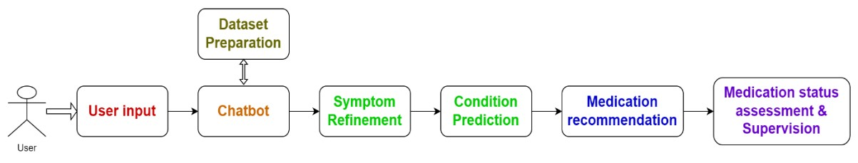
Fig. 1.1 Workflow Overview
3.1.Dataset Preparation:
In this phase, an extensive dataset comprising 131 symptoms, corresponding level 1 medications, and related disorders gathered. The dataset obtained from [10] is supplemented with elementary medications consistent to each disease as shown in figure 2. Various sources, including medical literature, databases, and expert consultations, were utilized to ensure the dataset's comprehensiveness and accuracy. Additionally, data preprocessing techniques such as normalization, cleaning, and validation were applied to ensure the dataset's quality and consistency.
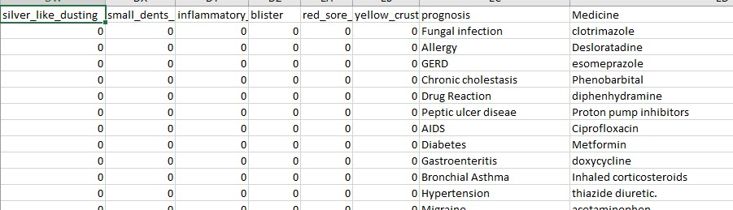

Fig. 1.2 some of the symptoms, diseases and medicine of dataset
- 2.Chatbot Development:
The chatbot interface was developed using Python programming language and ‘Streamlit [12]’ framework for creating a user-friendly web application.
3.2.1.Backend Development:
The libraries and functions that are used for the present work are as follows:
Imports: The necessary libraries are imported, including zipfile, os, csv, pandas (as pd), and streamlit (as st).
Functions:
extract_csv_from_zip: Extracts a CSV file from a ZIP archive. load_dataset: Loads the dataset from a CSV file using Pandas.
find_related_diseases: Finds related diseases based on selected symptoms from the dataset.
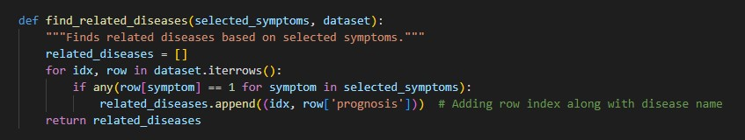
Fig 2.1 Code for finding related diseases function
find_related_medicine: Finds related medicine for the predicted disease from the dataset.
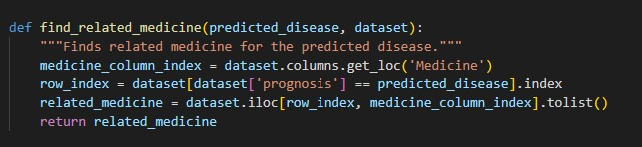
Fig 2.2 Code for finding related medicine function

Then, the user selects symptoms from different levels.
Based on the selected symptoms, the chatbot predicts related diseases and suggests medication accordingly.
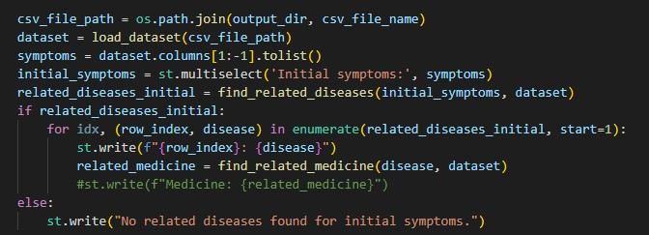
Fig 2.3 Prediction of diseases and Suggestion of medicine
Additionally, it prompts the user if they have taken any medication before, and if so, for how long, and whether there's any improvement.
Finally, it displays a message to take care and have a good day.--
Execution: The main () function is executed if the script is run directly.
Process Starts with a Streamlit interface, where the user provides information like name, feeling, gender, age, height, and weight. Overall, the code integrates user input, symptom analysis, disease prediction, and medication suggestion in a userfriendly web application interface using Streamlit.
3.2.2.Frontend for Integration and Deployment:
After completing the development of the backend functionalities[11] using
Python code, we integrated our software with a user-friendly graphical interface (GUI) [12] through the Tunnel website [13] to Streamlit[14], ensuring a smooth and intuitive user experience for accessing and interacting with our application.
The steps involved in it are:
3.2.2.1.Install Streamlit: Installation of Streamlit in our Python environment.
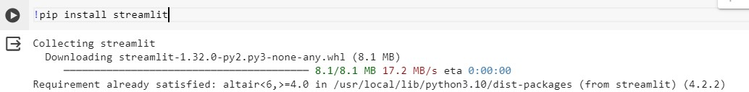

Fig 2.1 Installation of Streamlit
Download Public IP Address File: This is used to fetch the public IP address of our machine.
3.2.2.2.Run Streamlit App: Start the Streamlit app by running streamlit run app.py (The file in which our python code contains) in terminal. This command will launch the Streamlit server and run application.
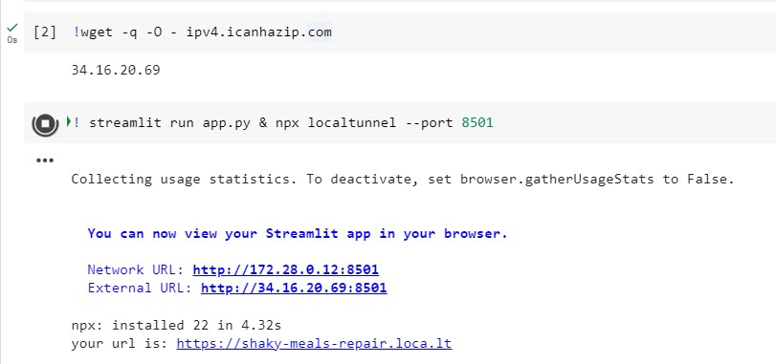
Fig 2.2 Run Streamlit app

Expose Local Server to Internet: Use a tunneling service (local tunnel) to expose our local Streamlit server to the internet. This allows others to access our application remotely.
Accessing the Streamlit App: Once the tunneling service is set up, we received a URL that can share with others to access our Streamlit app from anywhere.
(The IP Address generated is the Tunnel Password)
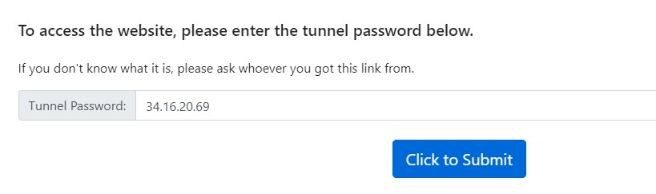
Fig 2.3 Accessing Streamlit through Tunnel Website The chatbot development covers the key aspects outlined below:
- User Interface Design:
Utilizes Streamlit to create a web app with various interactive components like text inputs, radio buttons, and number inputs to facilitate user interaction.

- Data Handling:
Manages symptom, disease, and medicine data stored in a CSV within a ZIP archive, utilizing zipfile and pandas for extraction and processing. This ensures efficient handling of data required for disease prediction and medication recommendation.
- Functionality Design:
Defines core functions including extracting CSV from ZIP, loading dataset, finding related diseases, recommending medicines, and implementing chatbot functionality. These functions form the backbone of the chatbot's operations.

- User Interaction Flow:
Guides users through a structured interaction flow, starting from information collection, symptom selection, disease prediction, medicine recommendation, and personalized advice based on user inputs as shown below figure 3.

- Output Presentation:
Utilizes Streamlit's text components to display user inputs, predicted diseases, recommended medicines, and advice. Conditional statements ensure tailored responses based on user interactions, enhancing the overall user experience.

- Error Handling:
Includes basic checks for missing inputs and handles empty datasets or extraction failures. This ensures the robustness of the chatbot by gracefully handling errors that may occur during execution.

- Overall Approach:
Ensures a smooth, usercentric experience by leveraging Streamlit and pandas for effective data management and interaction flow in the disease prediction chatbot. The methodology involves comprehensive user input gathering, symptom selection, disease prediction, medicine recommendation, user interaction, and output presentation to provide an intuitive and informative user experience.

3.3.Symptom Refinement
An algorithmic approach was devised to iteratively refine user provided symptoms through stages 1, 2, and 3.
Hierarchical symptom evaluation methodology was employed to classify symptoms into distinct categories, enabling a structured and thorough assessment process.
Dynamic interaction techniques were implemented to engage users and gather sufficient data for accurate disease prognosis.

3.4 Condition Prediction
Machine learning techniques were applied to analyze the refined symptoms and predict the most likely condition.
Feature selection, model training, and evaluation procedures were conducted to optimize prediction accuracy and reliability.
Model interpretability and transparency were prioritized to enhance user trust and understanding of the prediction outcomes.

3.5 Medication Recommendation
Level 1 medications were recommended based on the anticipated illness, ensuring relevance and timeliness of treatment suggestions.
Personalized medication recommendations were provided to users based on their medical history and symptoms, enhancing the relevance and effectiveness of the suggestions.
3.6 Medication Status Assessment and Supervision:
The chatbot assess the user's current medication status by inquiring about the type and duration of the prescription. It then monitors the situation, particularly through a threshold-based monitoring for further decision-making, and provides tailored advice based on the user's medication history, including recommendations for prescription renewal or consulting with a healthcare professional.

3.7 Chatbot Work flow
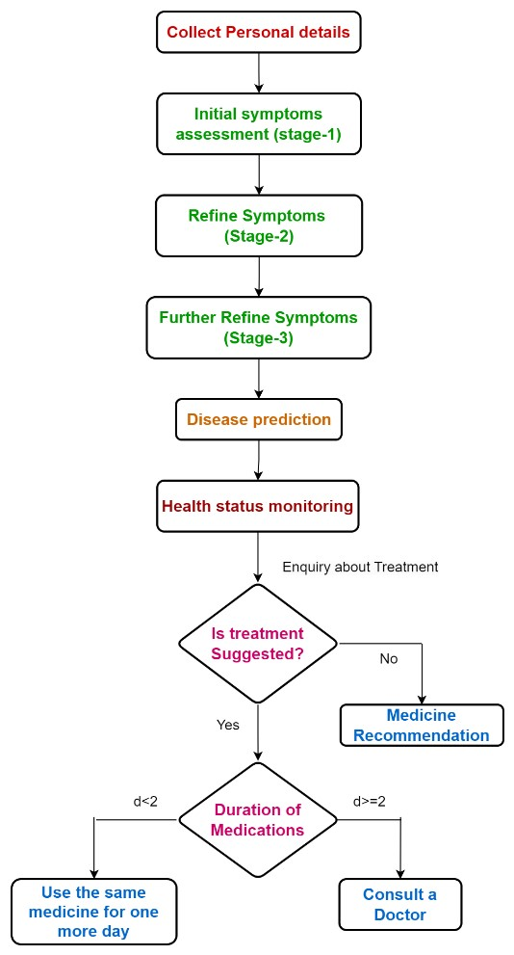

Fig 4.0 Chatbot Process Flow

- 8.Algorithmic Framework
3.8.1.Symptom Matching:
Tokenization: Each symptom in the dataset is represented as a token. Let's denote the set as S all symptoms, where ∣S∣ represents the total number of symptoms.
User-selected Symptoms: When the user selects symptoms, they create a set “U” containing the user's chosen symptoms.
Matching Score Calculation: The Matching Score(d) formula calculates the matching score for a disease "d" based on the number of common symptoms between the user-selected symptoms "U" and the symptoms associated with disease "d" denoted by "Dd". It is represented mathematically as:
|𝑈|
𝑀𝑎𝑡𝑐ℎ𝑖𝑛𝑔 𝑆𝑐𝑜𝑟𝑒 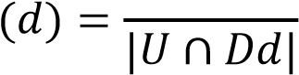
Where:
∣U∣ represents the total number of user-selected symptoms.
∣U∩Dd∣ represents the number of common symptoms between the user-selected symptoms and the symptoms associated with disease d.
3.8.2.Disease Prediction:
Maximum Matching Score: The disease with the highest matching score is predicted as the potential illness. Mathematically, the predicted disease d^ is determined as:
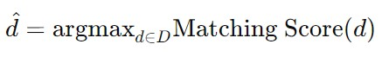
3.8.3.Decision Making:
Medicine Recommendation: Once the disease d^ is predicted, the associated medicine is retrieved. If the user has taken medication before and has seen improvement, the chatbot recommends continuing the same medication. Otherwise, it suggests consulting a doctor.
3.8.4.Uncertainty Modeling:
User Input Analysis: When the user provides information about previous medication and improvement, the chatbot assesses the situation probabilistically to make recommendations. For example, if the user has taken medication for a few days and seen improvement, the chatbot might recommend continuing the medication with a certain probability of success.

3.8.5. Statistical Analysis:
Probability Calculation: In cases where uncertainty is involved, the chatbot may calculate probabilities based on historical data or predefined rules to make recommendations. For example, if users who have taken medication for more than two days have a high likelihood of improvement, the chatbot would recommend continuing the medication with a high probability.
These mathematical calculations underpin the decision-making process of the chatbot, allowing it to provide relevant recommendations based on user input and symptom analysis.

CHAPTER-4
RESULTS AND DISCUSSION

4.1.Results
The integration of a chatbot model with a Graphical User Interface (GUI) developed using Streamlit, a popular Python library for creating web apps, represents a significant advancement in the accessibility and usability of the medical assistance system. The Streamlit app serves as the interface for users to interact with the chatbot. This graphical interface provides a user-friendly experience, enabling users to input their symptoms and receive personalized recommendations and disease predictions. To make the Streamlit app accessible over the internet, the Tunnel website is utilized to create temporary public URLs for the local server running the app. This integration ensures that users can access the chatbot from any internetconnected device securely.
The chatbot guides users through a systematic symptom refinement process, utilizing multiple levels to progressively narrow down possible illnesses. This hierarchical approach enhances accuracy in disease prognosis by categorizing symptoms effectively.

4.1.1. Choosing Initial symptoms for initial level
Initial user information including name, age, and first symptoms were collected to personalize the interaction experience. Interactive elements such as text inputs, radio buttons, and number inputs were incorporated to facilitate user interaction and data collection. The user interacts with the chatbot by selecting symptoms from a provided list initially. The chatbot interprets and processes natural language inputs from the user to understand their symptoms as shown in figure 5.1.
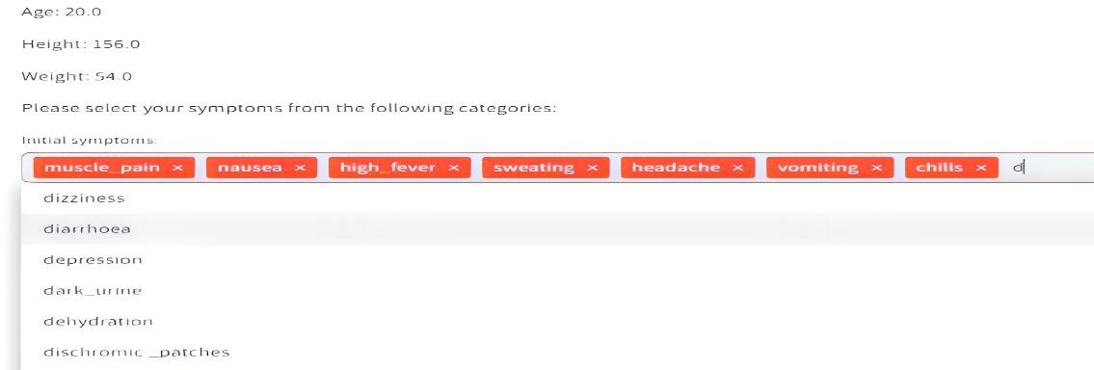
Fig 5.1 choosing initial symptoms for initial level
The choices made by the user represent linguistic expressions indicating their symptoms. The chatbot utilizes this information to narrow down the possible illnesses by identifying patterns and correlations between symptoms and diseases
As we select the initial symptoms from dropdown list provided, which is used to predict the diseases with their index numbers provided in the dataset as depicted in figure 5.2 This matching process involves comparing textual descriptions of symptoms with textual descriptions of diseases.
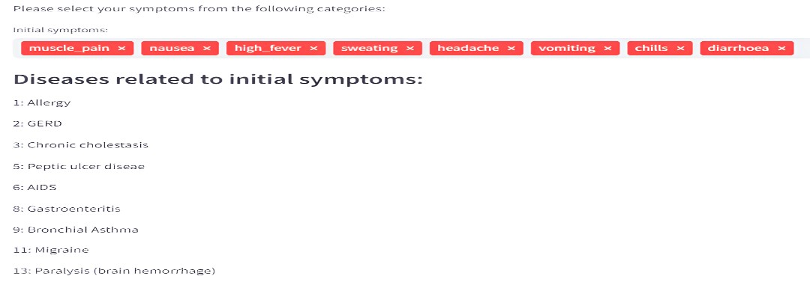
Fig 5.2 assessing symptoms for predicting initial level diseases

4.1.2.Prediction of Level-1 diseases
Users select initial symptoms from a dropdown list, which are then used to predict diseases at the initial level. Subsequently, users are prompted to select a subset of symptoms for Level-1 assessment, aimed at tracing the occurring diseases at this level. The process repeats for Level-2 assessment to further narrow down the predicted diseases as illustrated in figure 5.3, 5.4, 5.5, 5.6.
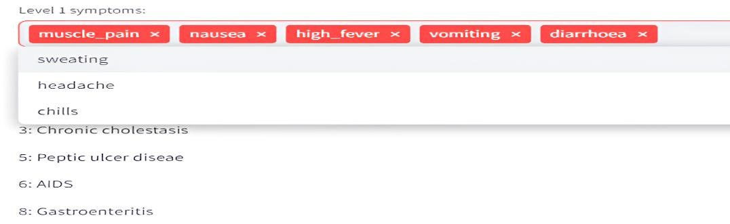
Fig 5.3 choosing symptoms for level
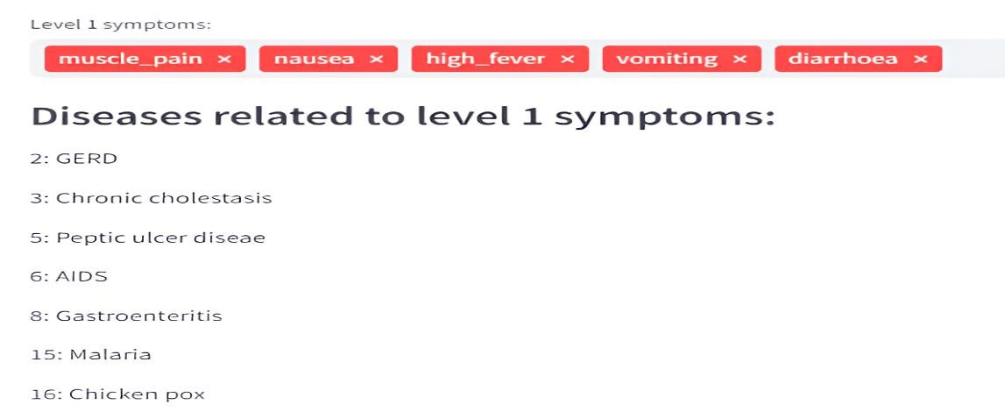
Fig 5.4 assessing symptoms for predicting level1 diseases

4.1.2.Prediction of Level-2 diseases
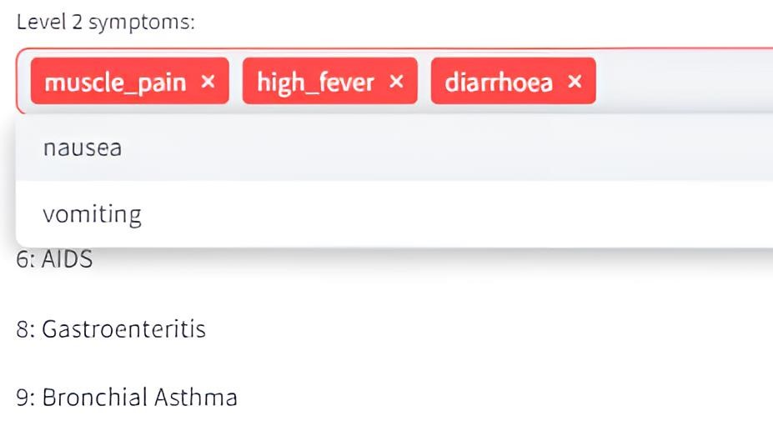
Fig 5.5 choosing symptoms for level2

4.1.3.Prediction of Level-3 diseases
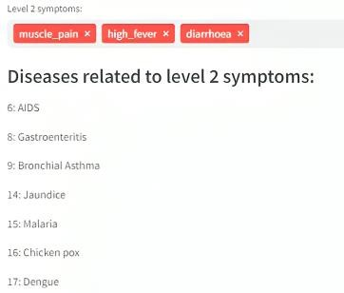
Fig 5.6 assessing symptoms for predicting level2 diseases
The procedure is repeated for screening the Level-3 Symptoms. Many diseases may be predicted to have the same symptoms, but our chatbot will only suggest the most likely one, the level-3 will figure the final disease upon the dominent symptom in choosen set of symptoms as shown in figure 5.7.
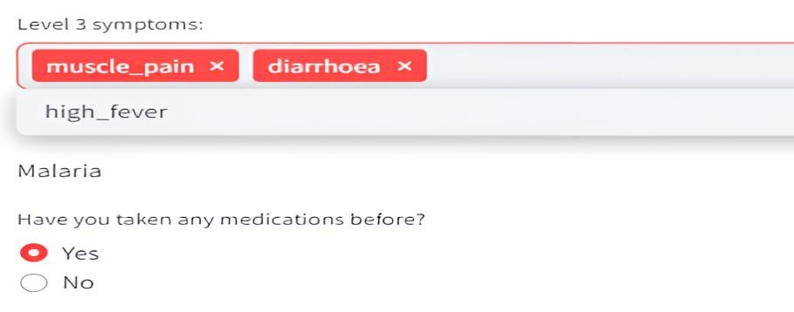
Fig 5.7 assessing symptoms choosen in level3 for disease prediction

4.1.5.Medicine Recommondation
It enquires about the medications and then recommonds the medicine as shown in figure 5.8.
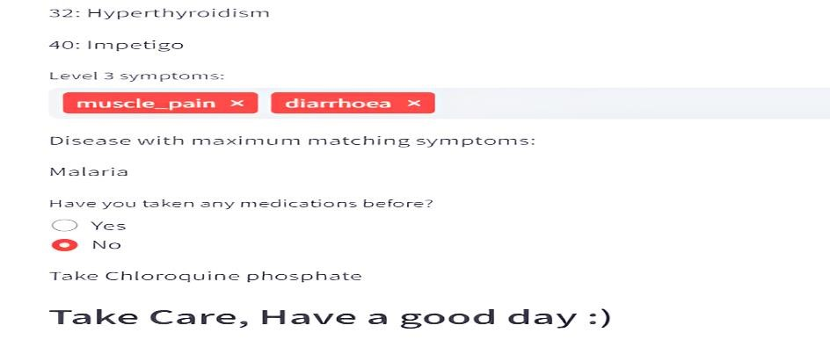
Fig 5.8 Medicine recommendation
The chatbot not only predicts diseases but also recommends medications based on the identified conditions. Additionally, it monitors the user's health based on specified threshold values, ensuring timely medical attention if necessary as shown in figure 5.9 .

4.1.6.Consultation Advice
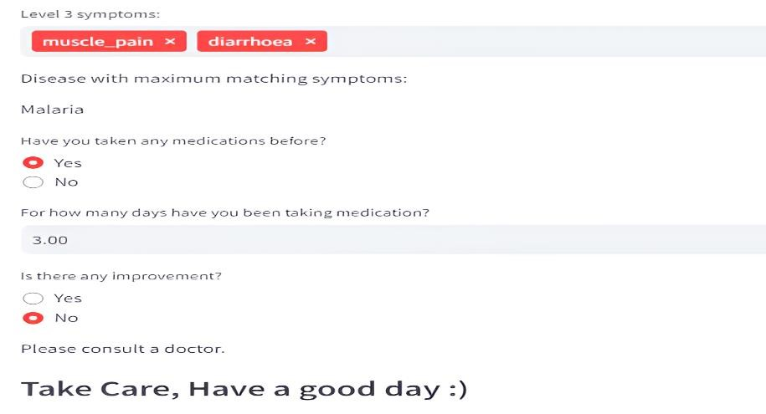
Fig 5.9 consultation advice

The chatbot generates output messages based on the user's input and the results of the symptom-disease matching. These messages are constructed using natural language to effectively communicate with the user.
The project revolutionizes virtual medical assistance by offering personalized medication recommendations and disease predictions tailored to individual symptoms and medical history. Using a hierarchical symptom evaluation method, our chatbot systematically categorizes symptoms for accurate disease prognosis. Through dynamic interaction, it refines symptom identification progressively, enhancing engagement and data accuracy. By evaluating current medication status and providing consultation advice, our chatbot empowers users to manage their health effectively. Implementing a two-day threshold for medical attention emphasizes timely care, aiming to prevent treatment delays and ensure optimal healthcare outcomes.
Overall, the integration of advanced technology with healthcare services demonstrates the potential to enhance medical assistance and improve patient outcomes through personalized, accessible, and timely interventions.
4.2.Evaluation and Validation:
Extensive testing and validation procedures were conducted to evaluate the chatbot performance in terms of disease prediction accuracy, medication recommendation efficacy, and user satisfaction. Real world user interactions and feedback were collected and kept to medical practitioners for scrutinizing to assess the chatbot usability, effectiveness, and overall impact on virtual health assistance.

CHAPTER-5 CONCLUSION

With the goal of improving healthcare accessibility and efficiency, we have successfully designed and assessed a chatbot system for disease prediction and medicine suggestion. Using a multistage symptom refining approach, our chatbot uses a comprehensive dataset with 131 symptoms with 41 diseases, in which we have added associated preliminary medicines. The system accurately identify diseases based on symptoms reported by the user. Our chatbot improves disease prediction accuracy and provides individualised medicine recommendations by conversing with users and leading them through various symptom refinement stages. With the extensive testing and validation, the developed chatbot is capable of correctly identifying illnesses and giving timely pharmaceutical recommendations. Additionally, our system promotes safe and informed healthcare decisions by providing customised suggestions based on the user's current medication status through the integration of a medication status assessment module. Our study offers a unique paradigm for conversational chatbot based disease prediction and drug recommendation, with potential applications in remote healthcare, telemedicine, and patient self-management.

CHAPTER-6
FUTURE SCOPE

For the purpose of enhancing the chatbots functionality and performance in actual healthcare settings, future development may concentrate on growing the dataset, improving the symptom refinement algorithm, and adding new features. The symptom diseases mapping can be done more accurately if a more reliable dataset is made available. Integration of smart wearables for precise body measurements such as heart rate and BMI can enhance disease prediction algorithms, leading to more accurate disease prognosis. Enhancements to the project include integrating features like video calls with doctors and linking the application with nearby hospitals. Improvements to the disease symptoms dataset involve validation by experienced medical personnel, ensuring consistency and enhancing prediction accuracy. Chatbot can be updated to a Virtual Assistant. Incorporating GPS functionality to track current location and display nearby hospitals and clinics.

REFERENCES:
- Covid19- Wikipedia - https://www.who.int/health-topics/coronavirus#tab=tab_1
- IBM -Chatbot technology- by -
https://www.ibm.com/topics/chatbots#:~:text=A%20chatbot%20is%20a%20compute r,and%20automate%20responses%20to %20them
- A COMPLETE GUIDE TO Natural Language Processing-
https://www.deeplearning.ai/resources/natural-languageprocessing/
- Gajendra Prasad K. C., Satvik Ranjan, Tathagat Ankit, Vivek Kumar, “A Personalized Medical Assistant Chatbot: MediBot”, International Journal of Science
Technology & Engineering | Volume 5 | Issue 7 | January 2019, ISSN (online): 2349784X, [academia.edu], [ijste]
[5]Mrs. Swathi S, Sushruth S, Rajamani R, Manjunath S, Ullas R, “Chatbot For Disease Prediction And Treatment Recommendation”, Turkish Journal of Computer and Mathematics Education Vol.12 No.10(2021), 397-401 [turcomat.org]
- J. Gupta, V. Singh and I. Kumar, "Florence- A Health Care Chatbot," 2021 7th International Conference on Advanced Computing and Communication Systems
(ICACCS), Coimbatore, India, 2021, pp. 504-508, doi:
10.1109/ICACCS51430.2021.9442006. [ieeexplore.ieee.org], [researchgate.net], [semanticscholar.org]
- Gori, K., Ahmed, Y.H., Chikane, S., & Mathur, A. (2021). MEDBOT: A CHATBOT FOR DETERMINING THE PROBABLE DISEASES BASED ON THE
USER'S SYMPTOMS. Issue:05/May-2021 [ irjmets.com]
- R. B. Mathew, S. Varghese, S. E. Joy and S. S. Alex, "Chatbot for Disease Prediction and Treatment Recommendation using Machine Learning," 2019 3rd
International Conference on Trends in Electronics and Informatics (ICOEI),
Tirunelveli, India, 2019, pp. 851-856, doi: 10.1109/ICOEI.2019.8862707 [semanticscholar.org] [ieeexplore.ieee.org]
- P. Srivastava and N. Singh, "Automatized Medical Chatbot (Medibot)," 2020 International Conference on Power Electronics & IoT Applications in Renewable Energy and its Control (PARC), Mathura, India, 2020, pp. 351-354, doi: 10.1109/PARC49193.2020.236624. [researchgate.net] [semanticscholar.org]
- Dataset-Disease Prediction Using Machine Learning, available at:
https://www.kaggle.com/datasets/kaushil268/diseaseprediction-using-machinelearning
- Backend Functionality- https://www.codecademy.com/article/back-endarchitecture
- GUI - https://intellipaat.com/blog/graphical-user-interface-gui/
- Tunnel website-https://localtunnel.me/
- Streamlit documentation- https://docs.streamlit.io/

